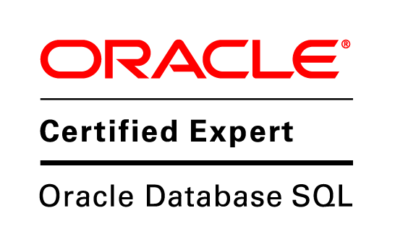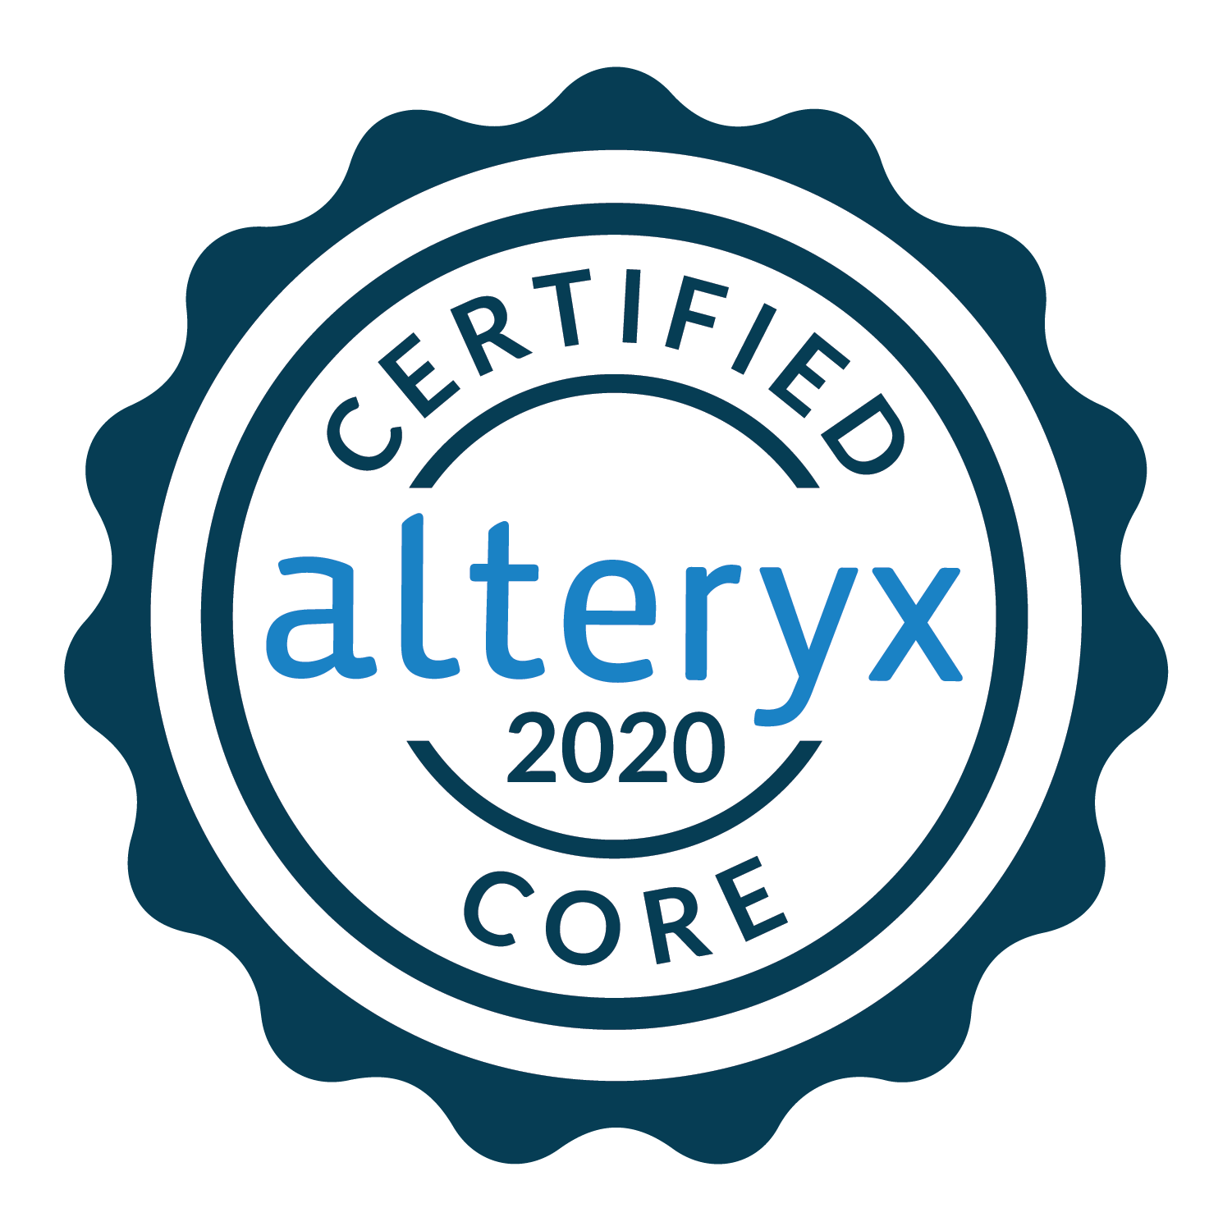

**R V KUMAR JONNALAGADDA**

**Mobile: +91-7013634872**

**Email :** [**rvkumar.jonnalagadda@gmail.com**](mailto:rvkumar.jonnalagadda@gmail.com)

**EXPERIENCE SUMMARY**

* Having total **9+ Years** of experience as software engineer in Information Technology with hands on experience on different technologies.
* Having **7+ Years** of experience as **ETL developer**  with hands on experience in the areas Data Warehousing and ETL using Informatica, Bodi, Diyotta, supporting data transformations using Oracle Data Integrator.
* Having **2+ Years** of experience as **Google Big Query developer in Google Cloud Platform** with hands on experience in Google Big Query Console, Google Cloud Function,Google VM Instance,Google Error Monitoring, Google cloud storage, Google Cloud dataflow, Google Pub/Sub, Google cloud shell, BQ command line utilities, Stack driver.
* Participated in requirement gathering along with BA’s and helped in preparing various requirement documents like low level documents and mapping documents.
* Involved in end-to-end ETL implementation that includes extract/load data from/to multiple source/target systems and transform it.
* Extensive experience in data warehousing tools including **ETL process** using different modules of Informatica Power Center like Designer, Workflow Manager, Workflow Monitor and Repository Manager.
* Strong experience with Informatica tools Mapping designer,Mapplet designer, transformation Developer,Repository Manager,Workflow Manager,Workflow Monitor.
* Experienced on various databases like **Oracle9i/10g, MS-SQL Server 2005 and Greenplum.**
* Worked extensively with Informatica Designer to create mappings using **Expression, Router, Lookup**(connected and Unconnected)**, Source Qualifier, Aggregator** and other transformations.
* Experience in full life cycle implementations in Data Warehouse area from designing Logical and Physical Data Models involving **Star** and **Snowflake schemas**.
* Expertise in implementing complex business rules by creating re-usable transformations, and Mappings/Mapplets.
* Integrate different source format of data into target using excel/csv/txt file, using Informatica.
* Expertise in importing data from Flat Files and different relational sources like Oracle, Greenplumand SQL Server.
* Extensively worked with Informatica performance tuning involving source level, target level and map level bottlenecks.
* Experience with **slowly changing dimension methodology Types**.
* Experience in developing Complex mapping using various transformations available in Mapping Designer also in setting up groups, users, permission for Informatica user in Repository Manager.
* Have good problem solving, time management skills, communication skills, good organizational skills, self-motivated, hardworking, ability to work independently or cooperatively in a team and eager to learn.
* Good Knowledge on Scheduling Tool IDR andScheduling Jobs using Informatica Scheduler and Knowledge in running the jobs using Unix Command.
* Good Knowledge on Software Testing,Unit testing,Database Testing,smoke testingandpreparing test case documents.
* Working closely with Onshore and offshore application development leads.
* Identified efficiencies and ways to improve design and development processes.
* Underwent AWS training and completed multiple POCs, having good knowledge on AWS Cloud services.
* Involved in the GCP training program conducted in my company to train fresher’s on multiple services in Google cloud Platform.

**ACADEMICS**

* Master of Computer Applications from **J.N.T University, Hyderabad.**

**WORK EXPERIENCE**

* Worked with **HONNEX SOFTWARE SOLUTIONS** Hyderabad from June 2012 to February 2014.
* Previously worked with **STRATAPPS SOLUTIONS** Hyderabad from March 2014 to September 2018.
* Currently working with **GENPACT INDIA** Hyderabad from November 2018 to Till Date.

**TECHNICAL SKILLS**

* **ETL/ELT Tools :** Informatica Power Center 8.X,9.X, IDR Tool,BODI,Diyotta, Alteryx, Attunity
* **Databases :** Oracle, SQL Server, Greenplum
* **AWS Cloud Services :** S3 bucket, EC2, Lambda, Dynamo DB, Red shift, Athena
* **GCP Services :** Google Big Query, Cloud Function, Google Pub Sub, driver monitoring,

VM Instance, Error Monitoring and GCS bucket(storage)

* **Database Utilities :** Toad,SQL Developer, SQL*PLUS, PGAdmin
* **Scripting Language :** Python
* **Reporting Tools : Tableau**
* **Scheduling Tools :** IDR,Informatica Scheduling
* **Operating Systems :** Windows Flavors, UNIX
* **Others : Software Testing, Automation Anywhere,Jira,Concourse and GitHub**

**CERTIFICATIONS**

* **ORACLE SQL Certified**
* **ALTERYX Designer Core Certified**

**PROJECTS**

**PROJECT #1:**

**Project : Data Engagement Platform**

**Client : Cardinal Health**

**Duration : May 2019 to Till Date**

**Environment : Google Cloud Platform (GCP), SQL, Google Big query, Cloud Function, Pub sub**

**Role : Google Big query Developer**

**Description:**

* The main objective of this project is to build DEP using Google Cloud native solutions in the areas of Data Movement, Data Storage, and Data Consumptions.
* Data engagement platform (DEP) solution is to build a normalized foundational FP&A data layer from multiple source systems into one single layer. The single layer will have harmonized, normalized & transformed data at most granular level with data lineage to trace back the transactions to source system. The DEP will solve purpose of single source of truth for all the management, period end & Ad-hoc reporting needs.
* Raw data from various source systems which are in scope for DEP across business units will be ingested to the Raw Zone (D0), and from D0 it will be moved to the prepared data zone (D1), and then further to the refined data zone (D2). This document will provide the various design pattern for building the interfaces between these three zones, and dependencies of those design patterns.
* Transformed data shall support analytic use cases / KPIs. The data shall enable data engineering teams to develop predictive and prescriptive analytics used to optimize key business processes.

**Roles & Responsibilities:**

* I work as a Data Engineer in the project and my Key responsibility is to build the Data Lake.
* The total number of resources working with this client is approx 35 and still growing.
* Interact with functional team to gain understanding of requirements using STTM(source-to-target-mapping) sheet.
* Involve in building of views/tables for different Data zones i.e. Landing, Collate, and Structured& Presentations using Google Big Query.
* Create different configuration tables & stored procedures for handling smooth flow of data from various data sources to final consumption layers.
* Design & Create Cloud Function using Python and other supported libraries for defining workflow of data ingestion & continuous updates.
* Perform ETL data integration using Cloud Function to create custom workflows to combine and blend various data sources and creating calculated fields used for consumption in reports.
* Maintain proficiency in programming languages, program development, testing and writing unit test scripts and run to validate data in final layer.
* Create Error Reporting & Alerting framework using various GCP services- Logging & Monitoring.
* Design and Create dashboard in Data Studio for auditing & error tracing in case of any job failures.
* Working in the production environment and working on the incidents raised in production and closing the issues.
* Analyse and fix defects found in testing & higher environments such as QA, Sandbox, New Release (NR), Production (Go Live) and work closely with team to close out all open defects.

**PROJECT #2:**

**Project : AHM Parent ID**

**Client : COX**

**Duration : November 2018 to April 2019**

**Environment : Informatica 10x, SQL, IDQ**

**Role : Informatica Developer**

**Description:**

COX is in telecom business and is a cable,internet,phone service provider. COX has both commercial

In addition,residential (individuals) customers. There is a concept of Parent Id for the accounts which different COX team needs to roll up the billing of multiple accounts of same organization (summary of bill or split bill). Hence, there are some rules in place to generate Parent Id to the accounts; multiple accounts will have same Parent Id.

Cox Business Parent Information Project, including the following:

* Replacement of the current FoxPro Parent ID generation process to Cox’s enterprise MDM
* Automation of Parent ID data generation, Automation of Date Steward review process for Parent .
* The ability to update customer Parent ID relationship in the UI interface manually

**Roles & Responsibilities:**

* Coordinated with Product owner on a regular basis to discuss the business requirements.
* We will get data after change in parent id DS team, whichgenerated in the previous monthly process and loaded in EDW.
* We build Informatica mappings to load the data from EDW with the updated parent id to the IDQ and we load the data from IDQ to EDW with the changed Parent id.
* We Developed Informatica ETL jobs to migrate the data from flat files to database and vice-versa.
* Developed Informatica logics to automate the Parent ID data generation for the data given from DS team.
* Implemented Error handling in Informatica to validate the data Integrity and data completeness for the data from the Flat File. Incorporated business logic for Incremental data loads on a daily basis.
* Involved in various Client Meetings to Share our Thoughts, Queries and Update the status on the Project.

**PROJECT #3:**

**Project : BODI Migration**

**Client : IDT**

**Duration : October 2017 to August 2018**

**Environment : Informatica 9x, SQL, SAP**

**Role : Informatica Developer**

**Description:**

This project is a Migration Project. We migrated the Code from one of the ETL Tool BODI to Informatica. In this, we are developing the new code based on the functions and logics in the BODI. Developed the logics using transformations for the functions in Bodi to load the data in to Informatica.

**Roles & Responsibilities:**

* Interacted with business users to understand the business requirements and translated business requirements into Data warehouse design.
* Analysed the BODI Mappings and Prepared the Mapping Documents, based on the Mappings in BODI,Prepared the Logics and developed the Mappings.
* We are developing mappings for the different source and target tables to load the data based on the functionality used in BODI.
* Extracted data from different source systems like Informix,SAP,Oracle and SQL Server, flat files to load the staging tables and the master tables.
* Created programming code using advanced concepts of Records, Collections and Dynamic SQL. Used advanced Bulk techniques (FOR ALL, BULK COLLECT) to improve performance by reducing context switching between SQL and PL/SQL engines.
* Work closely with architects and designers to deliver high quality code. Participated in code walkthroughs and review sessions with the development team.

**PROJECT #4:**

**Project : AML**

**Client : Scotia Bank**

**Duration : June 2016 to September 2017**

**Environment : Informatica 9x, SQL,Diyotta**

**Role : Informatica Developer**

**Description:**

Scotiabank is embarking on utilizing the Oracle environment for their users to gain valuable insights from the data available today in the various source systems. Scotiabank has collaborated with our company to support this initiative by leveraging Informatica solution for data movement and data integration.

**Roles & Responsibilities:**

* Understanding the project requirements clearly and Analysis on user business and Understanding the data models of Staging and OLAP.
* Design the mappings according to the requirement provided. We are following the agile process to deliver this project in time.
* From the Jirabacklog, we can select valuable story and deliver to the sprint. We follow complete agile process to deliver this project in time and identifying the risk of the project.
* Extracted data from different source systems /flat files/parameter files to load the staging tables and the master tables and worked extensively with front-end team to meet the business requirements.

**PROJECT #5:**

**Project : E2E LOADS**

**Client : VMware**

**Duration : March 2015 to May 2016**

**Environment : Informatica 9.x, Greenplum (PostgreSQL, SQL)**

**Role : Informatica Developer and Production Support**

**Description:**

VMware, the global leader in virtualization and cloud infrastructure, delivers customer-proven solutions that accelerate IT by reducing complexity and enabling more flexible, agile service delivery. This project the loads go on and user raises a ticket to the VM Support team when he faces any issue related to data in the reporting level. The project completely related to the production support where we worked on the issues related to data and solving the issues according to the user requirement.

**Roles & Responsibilities:**

* Interacted with business users to understand the business requirements.
* Coordination with offshore team for development and support activities.
* Extracted data from different source systems /flat files/parameter files to load the staging tables and the master tables. Translated business requirements into Data warehouse design.
* Worked extensively with front-end team to meet the business requirements.
* Developed various shell scripts for **ETL process**, to truncate the staging tables, to ftp the files from local server to remote, file validation scripts, file archive scripts, mailing scripts.

**PROJECT #6:**

**Project : XELArate**

**Client : VMware**

**Duration : May 2014 to February 2015**

**Environment : Informatica 9.x,Greenplum(PostgreSQL,SQL),Oracle,IDR**

**Role : Informatica Develo**per

**Description:**

VMware, the global leader in virtualization and cloud infrastructure, delivers customer-proven solutionsthat accelerate IT by reducing complexity and enabling more flexible, agile service delivery.XELArate aimed to build a new Customer Quotable Asset View (QAV) tool.

**Roles & Responsibilities:**

* Created test documents, deployment document and developed mappings in Informatica.
* Coded PSQL functions in Greenplum and SQL Queries in Oracle.
* Created sessions,workflows in workflow manager.
* Used IDR(Informatica Data Replicator) to fetch delta data into Staging area.
* Scheduled the ETL jobs in Informatica for the Hourly basis.
* Involved in code migration to upper environments QA,UAT using the versioning tool PERFORCE.

**PROJECT #7:**

**Project : Hindu networking**

**Client : Hindu networking, India**

**Duration : June 2012 to February 2014**

**Environment : Oracle**

**Role : Test Engineer**

**Description:**

Hindu Networking is the next generation Religious and Social networking services where members can stay in touch with their friends, connect with friends, share photos, discover new interests and exchange views on different topics. Hinduism is the oldest of the world's faiths and its origins is dated between 10,000 - 7,000 BC in present day India. Hinduism is a dharma or way of life evolved by the great sages and seers of ancient India.

**Roles & Responsibilities:**

* Reviewed design documents & business requirements to learn the function and scope of the application.
* Understanding Functional Requirements. Involved in writing and implementation of the Test Cases.
* Conducted Functionality testing during various phases of the application.
* Reported and tracked the bugs using Bug tracking system.
* Interacted with end to end team, business analysts, discussed technical problems, and reported bugs to meet the business requirements.